Size specifications:

Lidar v3 lite:  
(from datasheet) : 20\*48\*40 mm

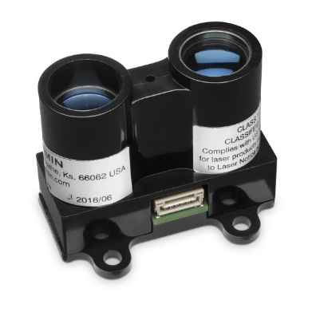   
Servo: see image below, sizes in mm.  
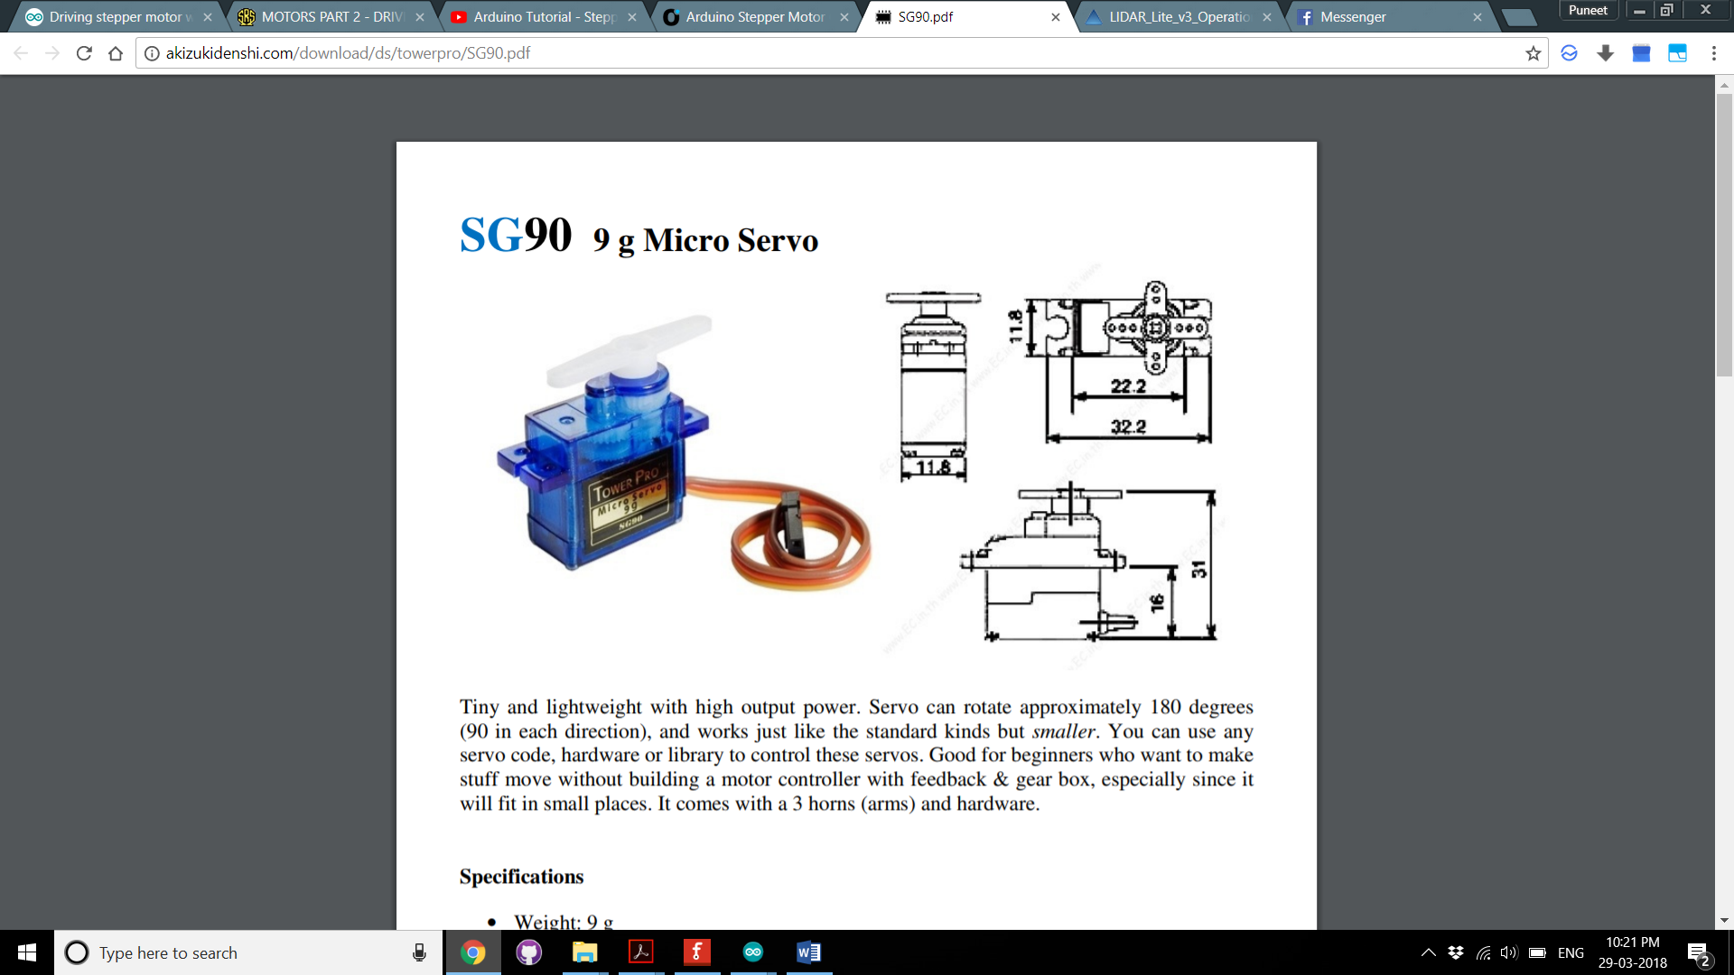  
  
Stepper motor (irrelevant to the size of the mount except axle diameter,sizes in mm) :   
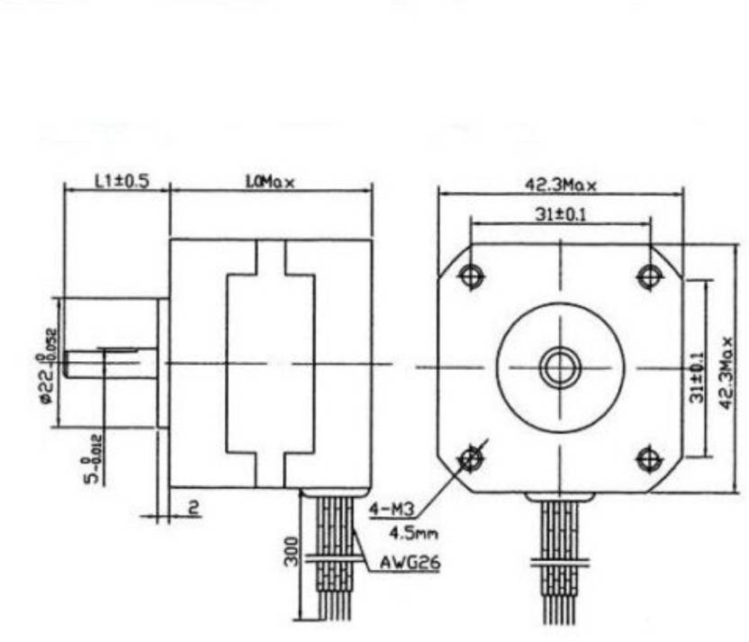

Top view

Side view

Mount Requirements :  
 Reference Structure :   
 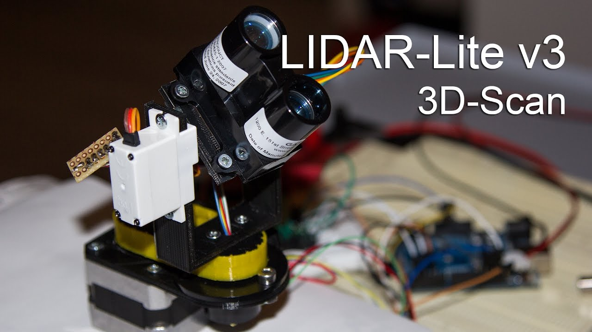

We need similar orientation of servo and Lidar

Do not require the gear chain mechanism, can directly be driven the motor